# Database files

**Program1: Create COLLEGE DATABASE:**

**STUDENT (USN, SName, Address, Phone, Gender)**

**SEMSEC (SSID, Sem, Sec)**

**CLASS (USN, SSID)**

**SUBJECT (Subcode, Title, Sem, Credits)**

**IAMARKS (USN, Subcode, SSID, Test1, Test2, Test3, FinalIA)**

**Program2: Write queries to execute following DDL commands :**

**CREATE :Create the structure of a table with at least five columns**

**ALTER:Change the size of a particular column.**

**Add a new column to the existing table.**

**Remove a column from the table.**

**DROP: Destroy the table along with its data**.

**To create database**

Create database college

**For using database**

Use college

**Table 1 Query**

create table student(Name varchar(45), USN int_,Phone int, Address varchar(45))

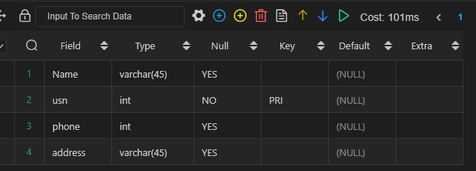

2.create table semsec(SSID varchar(20), Sem varchar(2), Credits varchar(2))

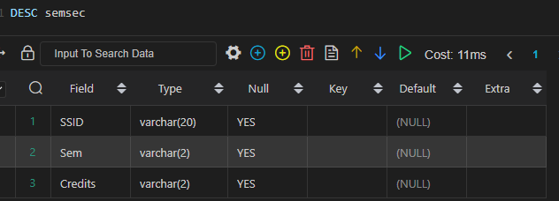

3. Create table class(USN varchar(10), SSID varchar(20))

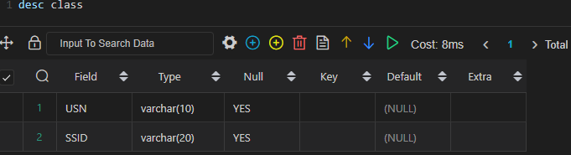

create table subject(Subcode varchar(8), Title varchar(50), Sem varchar(2), Credits varchar(2))

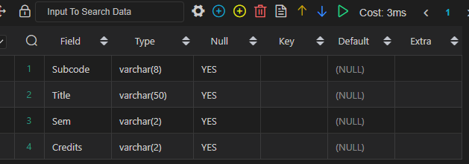

5. create table iamarks(USN varchar(2), Subcode varchar(10), SSID varchar(30), Test1 varchar(10), Test2 varchar(10), Test3 varchar(10), FinalIA varchar(10))

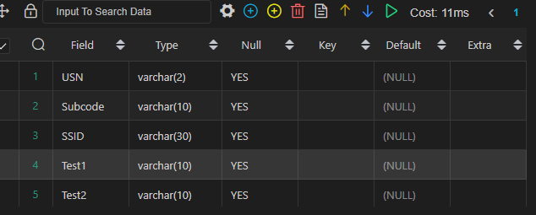

**Use of ALTER TABLE Statement**

1)For adding column

alter table subject add Shift varchar(2)

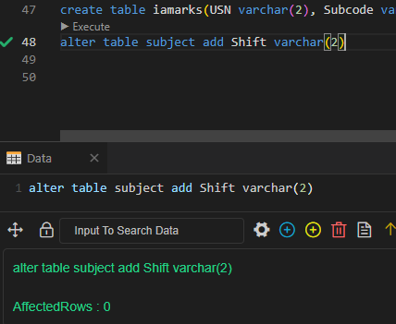

2) For modifying column name

alter table subject modify Shift varchar(10)

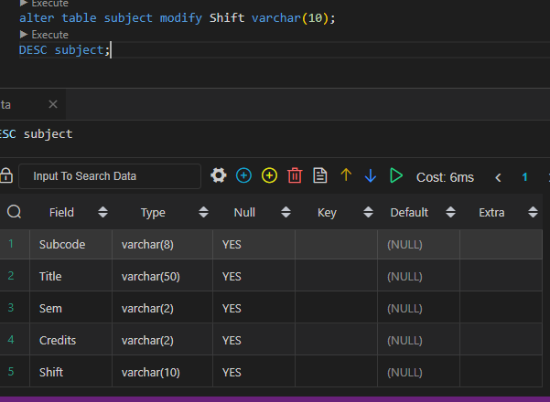

3) For removing a column in a table

alter table subject drop Shift



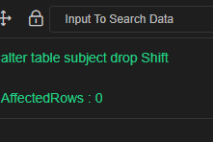

**Using ALTER with RENAME Statement**

alter table semsec rename column Sem to SEM

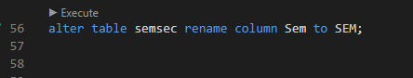

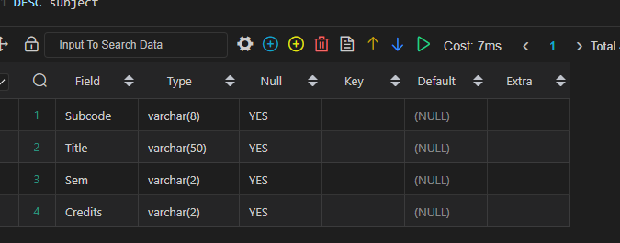

**Program3: Write queries to execute following DML commands :**

**INSERT: Insert five records in each table.**

**UPDATE: Modify data in single and multiple columns in a table**

**DELETE: Delete selective and all records from a table**

**Using INSERT statement**

**For Table 1**

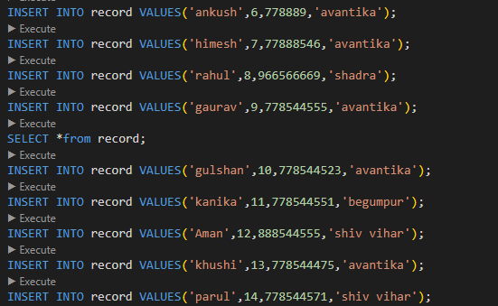

For table 2:

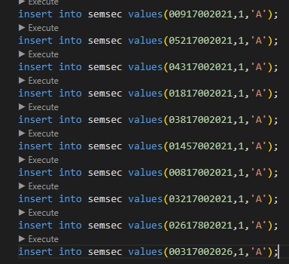

**For Table 3**

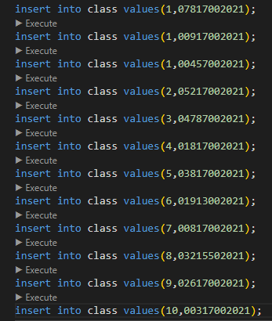

**For Table 4**

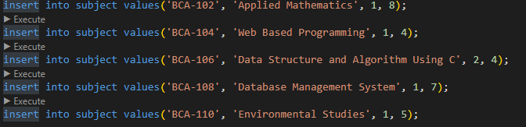

For table 5:

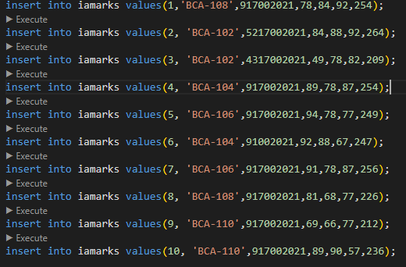

delete from subject where Subcode= 'BCA-112'



**Using UPDATE Command**

update iamarks set Test1= 84 where SSID= 917002021



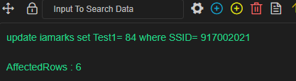

**For updating multiple columns**

update iamarks set Test2= 86, FinalIA= 262 where USN= 1

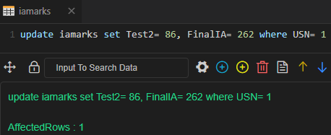

**Program4: Write queries to execute following DML command :**

**SELECT: Retrieve the entire contents of the table.**

**Retrieve the selective contents (based on provided conditions) from a table.**

**Retrieve contents from a table based on various operators i.e. string operators,**

**logical operators and conditional operators, Boolean operators.**

**Using COUNT in select statement**

1) For selecting count of all columns

select count(*) from student

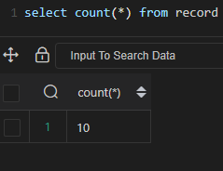

2) For selecting values with condition

Select count(Name) from record where address=’begumpur’

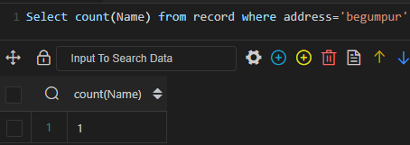

3) For selecting distinct values

Select count(phone) from record where USN= 5

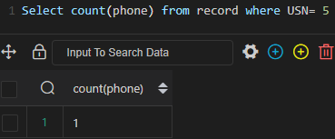

**Using String operators**

select USN, Name, Address from record where Name like 'Vish%';

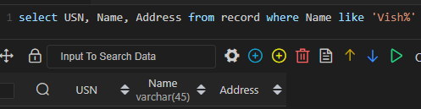

select USN, Name, Address from record where Name like '_H$';

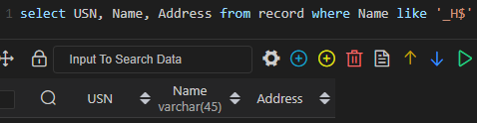

select USN, Name, Address from record where Name like '%a_';

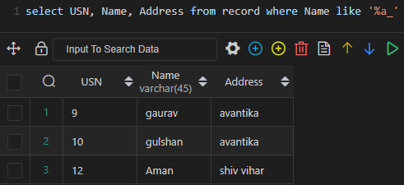

**Using Arithmetic Operators**

Select 21+45



Select 76-34

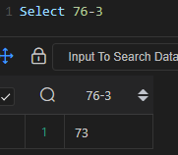

Select 12*13

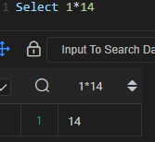

Select 121/19

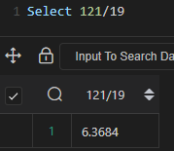

**Using Logical Operators**

select *from iamarks where Test1<=75

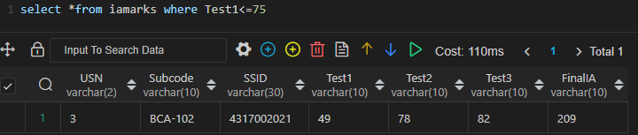

select *from iamarks where FinalIA>=250

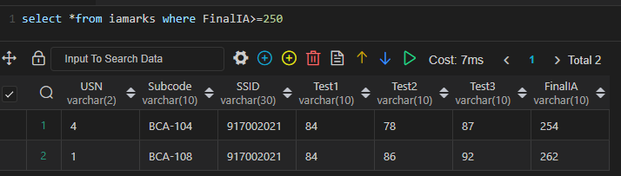

select *from iamarks where Test1<=70 || Test2<=60;

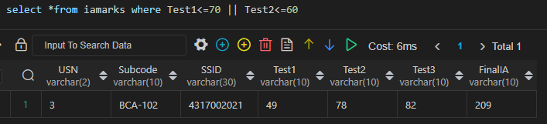

**Use of BETWEEN Condition**

select *from iamarks where FinalIA between 250 and 257

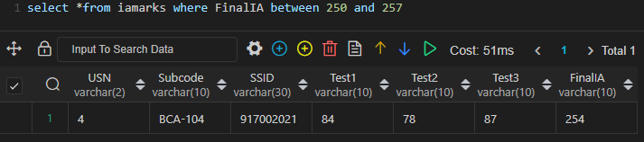

**Use of IN condition**

select *from record where Address in ('avantika', ‘begumpur')

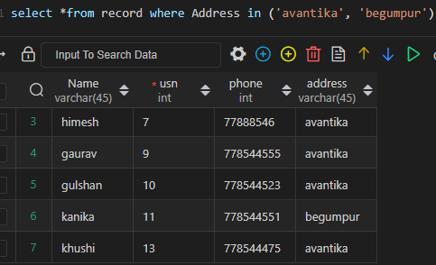

**Use of NOT in BETWEEN and IN**

select *from iamarks where FinalIA not between 250 and 260

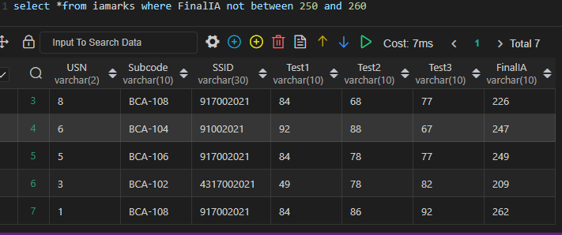

select *from record where Address not in (‘avantika',’begumpur’)

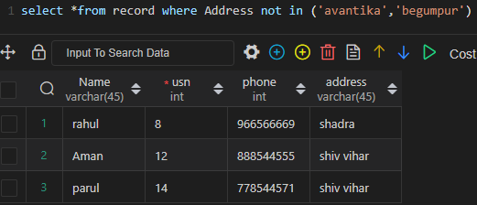

select *from record where USN between 1 and 10 and USN not between 5 and 10

select *from record where USN between 1 and 10 and USN not in (4,5,6)

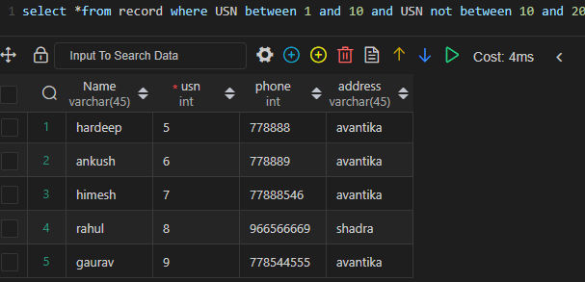

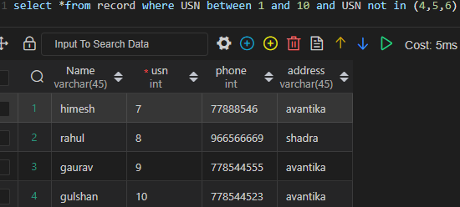

**Using ORDER BY Statement**

select *from record order by Name

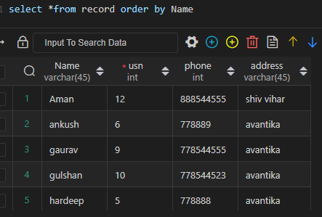

select *from record order by Name desc

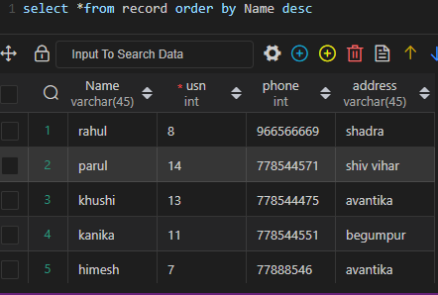

**Program5: Sort the data in ascending and descending order in a table on the basis of one**

**column or more than one column.**

**Sorting a table in ascending and descending order:**

select *from iamarks order by USN ASC;

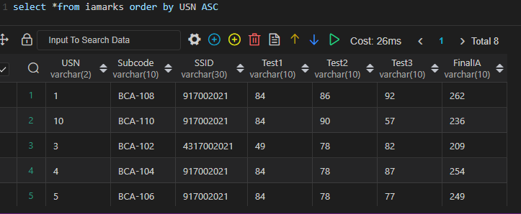

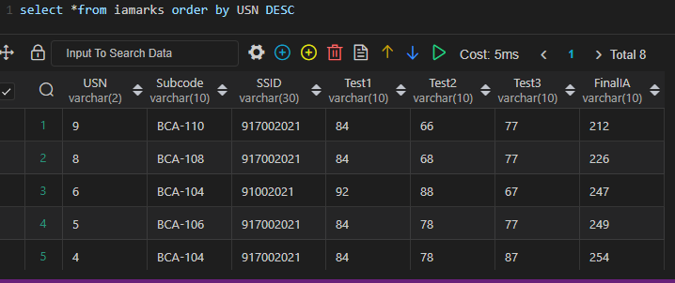

**Program6: Create table using following integrity constraints:**

**Primary Key**

**Unique Key**

**Not Null**

**Check**

**Default**

**Foreign Key**

**Queries for PRIMARY KEY, UNIQUE KEY, NOT NULL, CHECK, DEFAULT, FOREIGN KEY:**

alter table record add primary key (USN);



alter table record add unique key (Name);

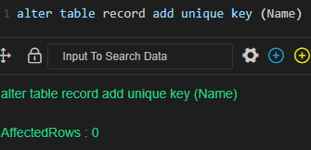

ALTER TABLE record MODIFY USN varchar (2) NOT NULL;

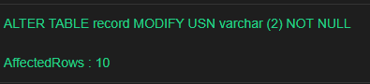

 ALTER TABLE record ADD CHECK (USN>=0);

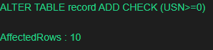

ALTER TABLE record ALTER Address SET DEFAULT ‘rohini';

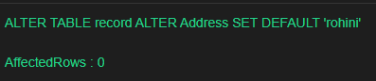

insert into record (USN, Name, Phone, Gender) values (11, 'Muskan',9013061623,'F');

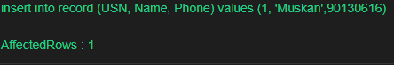

alter table iamarks add FOREIGN KEY(USN) REFERENCES record (USN);

select Test3, Phone from iamarks, record;

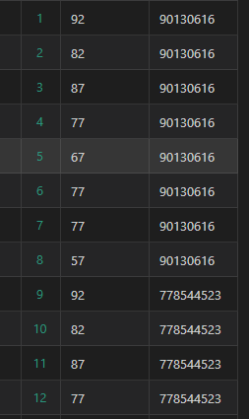

**Program7: Write queries to execute following Aggregate functions**

**Sum, Avg, Count, Minimum and Maximum value of a numeric column of a table**

**using aggregate function**

**Using aggregate functions**

**Using COUNT**

SELECT COUNT(Name) FROM record WHERE address= ‘avantika’;

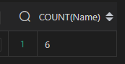

**Using AVERAGE**

SELECT AVG(Test2) FROM iamarks WHERE Subcode= 'BCA-110';

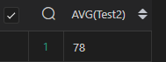

**Using SUM**

SELECT SUM(Test3) FROM iamarks WHERE Subcode= 'BCA-108';

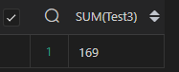

**Using MINIMUM**

SELECT MIN(FinalIA) FROM iamarks WHERE USN= 5;

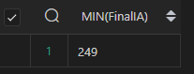

**Using MAXIMUM**

SELECT MAX(FinalIA) FROM iamarks WHERE USN= 9;

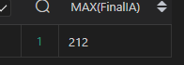

**Program8: Retrieve data from a table using alias names**

**Using ALIAS Statement**

SELECT SSID, SEC FROM semsec AS Semester;

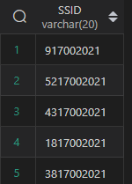

**Program9: Retrieve data of a table using nested queries.**

**Using NESTED Queries**

select *from record where USN < (select count (USN)/2 from record);

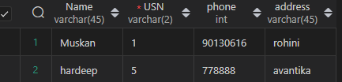

**Program10: Retrieve data from more than one table using inner join, left outer, right outer**

**and full outer joins**

**Using INNER JOIN, FULL JOIN, LEFT JOIN and RIGHT JOIN**

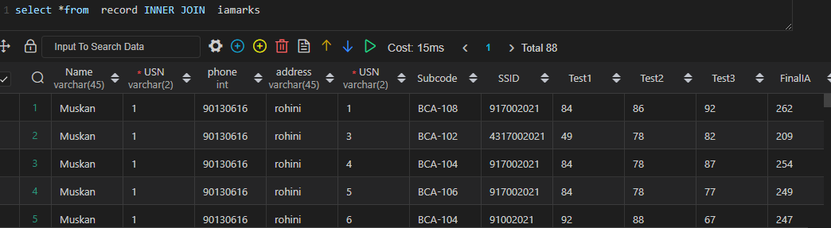

select *from record LEFT JOIN Demo on record. SNo= Demo. SNo;

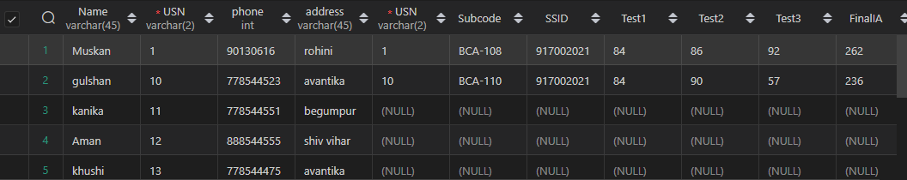

select *from record RIGHT JOIN iamarks on record.usn =record.usn;

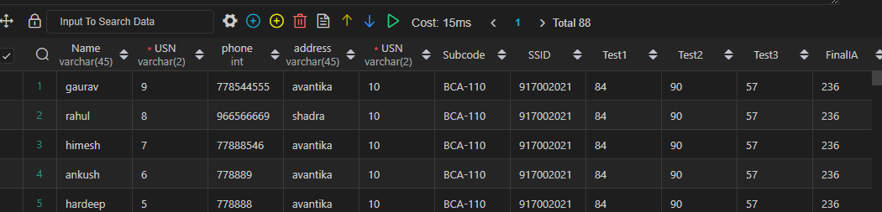

**Program11: Create view from one table and more than one table.**

**Using VIEW query**

**For one table**

create view past as select Name from record where usn>=0;

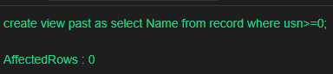

**For more than one table**

create view present as select Name, Name from record, iamarks where record.usn = iamarks.usn;

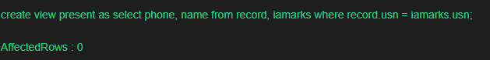

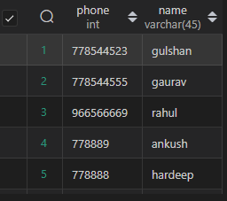

**Practical:- 12** Create index on a column of a table.

use hello;

SELECT * FROM best1;

create index index_Tias on best1(FName, Program, Tias_ID);

show index from best1;

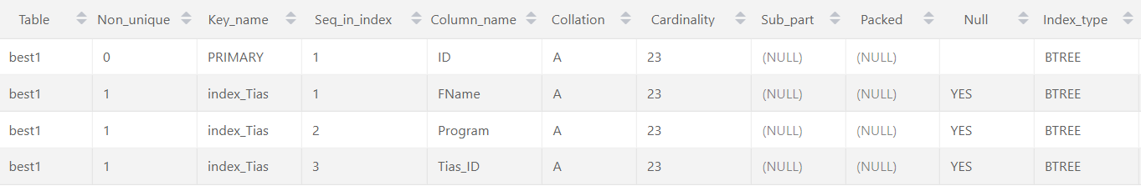

drop index index_Tias on best1;

**Practical:- 13** Consider the Insurance company’s Database given below.

The primary keys are underlined and the data typesare specified.

PERSON(driver_id# : string, name : string, address : string)

CAR(regno : string, model : string, year : int)

ACCIDENT(report_number : int, acc_date : date, location : string)

OWNS(driver_id# : string, regno : string)

PARTICIPATED(driver_id# : string, regno : string, report_number : int, damage_amount :number(10,2) )

1. Create the above tables by properly specified the primary key and the foreign key
2. Enter at least five tuples for each relation
3. (A)Demonstrate how you can a. Update the damage amount for the car with a specific regno, the accident with report number 12 to 25000.

(B). Add a new accident to the database.

Find the total number of people who owned cars that were involved in accident in2002

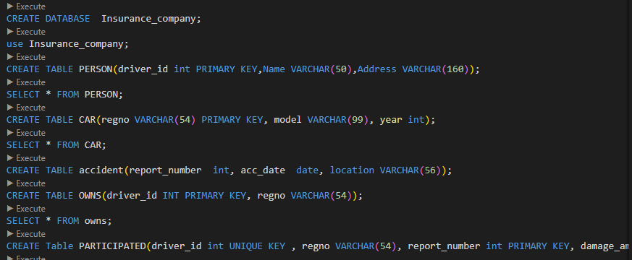

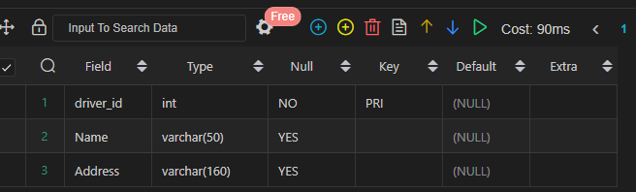

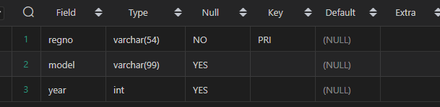

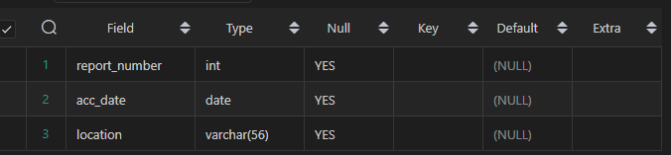

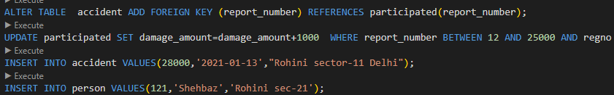



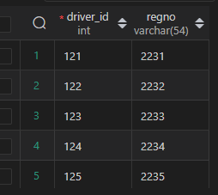

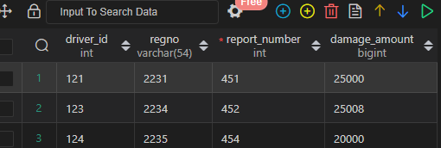

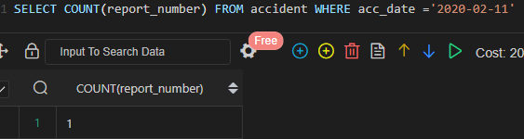

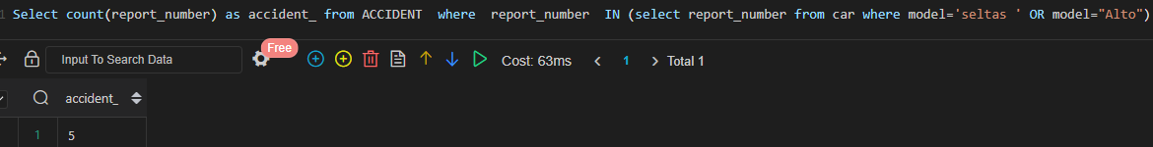

# Program-14

-- Consider the following schema of a library_management system.Write the SQL

-- queries for the questions given below;

-- Student(Stud_no : integer, Stud_name: string)

-- Membership(Mem_no: integer, Stud_no: integer)

-- Book_(book_no: integer, book_name:string, author: string)

-- lss_rec_(iss_no:integer, iss_date: date, Mem_no: integer, book_no: integer)

-- (i) Create the tables with the appropriate integrity constraints

-- (ii) Insert around 10 records in each of the tables

-- (iii)Display all records for all tables

-- (iv)List all the student names with their membership numbers

-- (v) List all the issues for the current date with student and Book names

-- (vi) List the details of students who borrowed book whose author is Elmarsi & Navathe

-- (vii) Give a count of how many books have been bought by each student

-- (viii) Give a list of books taken by student with stud_no as 1005

-- (ix) Delete the List of books details which are issued as of today

-- (x) Create a view which lists out the iss_no, iss _date, stud_name, book name

